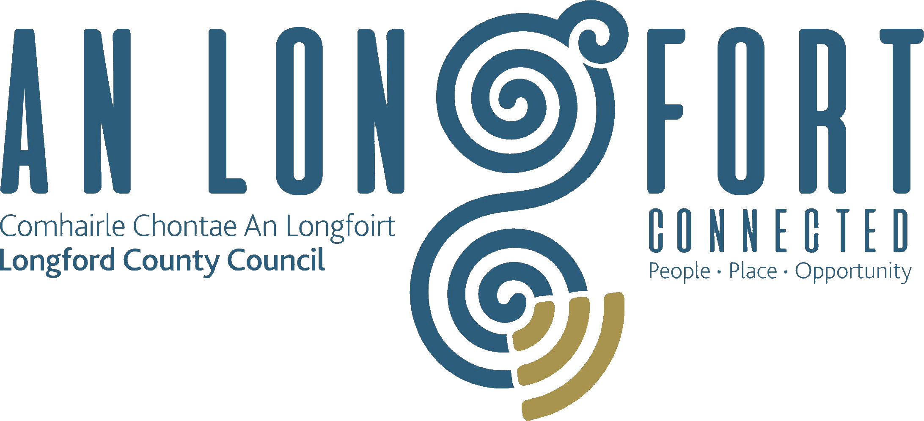

Minutes of Monthly Meeting of Longford County Council
held in The Village Inn, Drumlish on
Wednesday, 13th December 2017 at 4.00 p.m.

PRESIDING: Councillor Martin Mulleady, Cathaoirleach.

MEMBERS PRESENT: Councillors – Paraic Brady, John Browne,
Seamus Butler, Mick Cahill, Micheál Carrigy,
Mark Casey, John Duffy, Gerard Farrell,
Joe Flaherty, Luie McEntire, Colm Murray, Peggy Nolan,
Pat O’Toole, P.J. Reilly, Paul Ross, Mae Sexton and
Gerry Warnock.

IN ATTENDANCE: Mr. Paddy Mahon, Chief Executive.
Mr. John McKeon, Head of Finance.
Ms. Barbara Heslin, Director of Services.
Mr. John Brannigan, Director of Services.
Mr. Donal Mac An Bheatha, Senior Planner.

MEETINGS
ADMINISTRATOR: Ms. Anne Lee.

ADOPTION OF MINUTES.

On the proposal of Councillor M. Sexton seconded by Councillor P.J. Reilly, the Minutes of Monthly Meeting of Longford County Council held on the 8th November 2017, as circulated, were confirmed and adopted.

On the proposal of Councillor M. Sexton seconded by Councillor P.J. Reilly, the Minutes of Finance Committee Meeting of Longford County Council held on the 20th November 2017, as circulated, were confirmed and adopted.

On the proposal of Councillor M. Sexton seconded by Councillor P.J. Reilly, the Minutes of Budget Meeting of Longford County Council held on the 27th November 2017, as circulated, were confirmed and adopted.

MATTERS ARISING FROM MINUTES.

None

FILLING OF VACANCY OCCASIONED BY THE RESIGNATION OF
COUNCILLOR PADRAIG LOUGHREY.

A. Lee, Meetings Administrator, read the following correspondence to the meeting:-

(a) Letter dated 27th November 2017 received from Mr. Joe Flaherty stating that in accordance with the provisions of Section 19(3) of the Local Government Act 2001, he has given consent to his nomination by the Fianna Fail party as co-optee to Longford County Council to fill the casual vacancy created by the resignation of Councillor Padraig Loughrey.
(b) Letter dated 27th November 2017 received from Mr. Mr. Sean Dorgan, Fianna Fail General Secretary notifying Longford County Council that in order to comply with S.19(3) of the Local Government Act 2001, the Fianna Fail Party have selected Mr. Joe Flaherty to fill the casual vacancy on Longford County Council created by the resignation of Councillor Padraig Loughrey.

Councillor S. Butler proposed and Councillor M. Cahill seconded that
Mr. Joe Flaherty be elected to the vacancy for the Longford Electoral Area, occasioned by the resignation of Councillor Padraig Loughrey

The Cathaoirleach, Councillor Martin Mulleady, invited Councillor Flaherty to join the meeting of the Council.

The Members welcomed Councillor Flaherty onto Longford County Council and wished him every success.

Councillor Flaherty thanked his proposer and seconder and the Fianna Fail party for his nomination to replace Padraig Loughrey. He praised Padraig Loughrey for his outstanding work while a member of Longford County Council and stated it is a great honour for him and his family to be co-opted to the Council to replace Padraig. Councillor Flaherty stated that he will endeavour to give his best to the Council.

The Chief Executive, on his own behalf and on behalf of the staff of the Council, welcomed Councillor Flaherty to the Council and assured him of the assistance and support of the staff.

MEMBERSHIP OF COMMITTEES.

Consequent on the resignation of Councillor Padraig Loughrey, Councillor Joe Flaherty was appointed to the following Committees –

- Longford Pool Construction Ltd.
- Local Traveller Accommodation Consultative Committee.
- County Longford Heritage Forum.
- Joint Policing Committee.
- Economic Development and Enterprise Strategic Policy Committee.

CORPORATE POLICY GROUP MINUTES.

The adopted Minutes of Corporate Policy Group Meeting held on the 11th October 2017
as circulated, were noted.
CHIEF EXECUTIVE ORDERS.

The Chief Executive Orders, as circulated, were noted.

MONTHLY MANAGEMENT REPORT.

The Monthly Management Report, as circulated, was noted.

FINANCE & INFORMATION SYSTEMS.

Public Liability Claims.

It was noted that three Public Liability Claims were received during November 2017.

Statutory Audit Report for the year ended 31st December 2016

J. McKeon, Head of Finance, briefed the members on The Local Government Audit Service Statutory Audit Report for the year ended 31st December 2016, which was circulated, with the Agenda.

In reply to a request from Councillor S. Butler that reserves be used for works in the Municipal Districts, in particular refurbishment of footpaths in Longford town, J. McKeon stated that this request can be considered in conjunction with the 2018 Capital Programme in March 2018.

HOUSING, INFRASTRUCTURE, ENVIRONMENT & EMERGENCY SERVICES.

Disposal of Freehold Interest of Property at No. 9, The Demesne, Longford.

On the proposal of Councillor Seamus Butler seconded by Councillor Gerry Warnock, it was unanimously agreed to the disposal of Freehold Interest of Property at No. 9, The Demesne, Longford to Padraig Nugent in accordance with the terms of Section 183 of the Local Government Act 2001 issued on the 13th November 2017.

Disability Action Plan.

On the proposal of Councillor G. Warnock seconded by Councillor M. Sexton, it was unanimously agreed to adopt the Disability Action Plan, as circulated.

Notices of Motions.

Review of Housing Maintenance Policy.

The following Notice of Motion was proposed by Councillor G. Warnock and seconded by Councillor M. Casey -

“I am proposing that Longford County Council initiate a review of our Housing Maintenance Policy with particular emphasis on updating our policy in respect of Heating Systems;
Securing and Clearing Voids; and putting in place formal procedures and structured
timelines to enable us to process requests in a more uniform and expedient manner thus
delivering a more efficient service to customers and limiting the Council’s exposure to
potential public liability issues. I am further proposing that this item be placed on the agenda for the next meeting of the Housing Strategic Policy Committee for consideration.”

It was agreed that Housing Maintenance Policy will be considered at the next Housing Strategic Policy Committee. John Brannigan confirmed to the members that the structure of the housing maintenance section will be reviewed.

Review of Income Thresholds for Housing Support.

The following Notice of Motion was proposed by Councillor G. Warnock and seconded by Councillor M. Casey -

“I am proposing that Longford County Council again writes to the Minister for Housing and An Taoiseach to reinforce the need to carry out a review of the Income Thresholds to qualify for Housing Support with a view to increasing the maximum thresholds to adequate levels reflecting the soaring costs of rent in the private accommodation since thresholds were introduced in 2011. The current restrictions are prohibiting families on relatively low incomes from applying for Housing Support

It was agreed that a letter be sent to the Minister for Housing, Planning and Local Government and An Taoiseach requesting that the relevant thresholds be reviewed and that this issue be considered by the Housing Services Strategic Policy Committee.

ECONOMIC AND COMMUNITY DEVELOPMENT, PLANNING, HUMAN RESOURCES & CORPORATE SERVICES, CULTURAL & RECREATIONAL SERVICES.

Planning Applications.

The list of Planning Applications received since the last meeting of the Council was submitted and noted.

Review of Corporate Plan 2015–2019 and Equality and Human Rights Statement .

On the proposal of Councillor M. Sexton seconded by Councillor P. Nolan, it was unanimously agreed to adopt the Review of Corporate Plan 2015–2019 and Equality and Human Rights Statement, as circulated.
Wet and Wild Lands - A Shared Ambition, the roadmap for the development of Lough Ree and the Mid-Shannon.

Donal Mac An Bheatha gave a comprehensive presentation regarding the Lough Ree and Mid-Shannon Wet and Wild Lands – A Shared Ambition project.

The Shared Ambition project aims to capitalise on the region’s pivotal location in relation to the emerging blue and green off-road network and its natural setting within, between and across wet and wild lands. The aim is to activate the potential of the current and emerging wild places of Lough Ree and the Mid-Shannon for local people and their livelihoods, for visitors and for ecosystem services. This Shared Ambition establishes a strong footing for a regional, inter-county approach to strategic development in the Midlands.

The members complimented Donal on his excellent presentation and work to date on this project.

Donal and Barbara replied to queries raised on the following issues –

- Camlin River Feasibility Study - to be considered further by Longford Municipal District.
- Signposting – Donall confirmed that work is ongoing regarding the provision of signage for tourist areas in the County.

The Elected Members gave the Shared Vision their unanimous approval and endorsement. They also expressed their strong support for the shared ambition and looked forward to implementing the action plan.

Update on Northern Quarter and sale of Connolly Barracks

Barbara Heslin provided a detailed update on progress since the Budget Meeting. She emphasised that the information contained in the update was commercially sensitive and must be treated in the strictest confidence as the process is still ongoing. She said that the process clearly delivered renewed interest in the shopping centre and achieved the objective of increasing the profile of Longford as a place to invest and do business. The Best Bids closing date was Friday 20 October 2017, with four offers received - three for entire Northern Quarter and one for the shopping centre only.

NAMA/Receivers confirmed at a meeting on 12th December that the sales transaction for the shopping centre was at an advanced stage and they are working towards completion by year end. This is a very positive outcome for Longford Town as it will see increased activity and footfall in the area.

Meetings were held on 29th November with two parties that expressed an interest in Connolly Barracks. Following those meetings and consideration of the possible alternatives, the Executive recommended that Longford County Council does not at this stage sell Connolly Barracks and reserve the right to further engage with interested parties following completion of the Shopping Centre sale. This recommendation was proposed by Councillor Mae Sexton seconded by Councillor Gerry Warnock and unanimously agreed by the Elected Members.

Political Donations.

Political Donations- Local Elections (Disclosure of Donations and Expenditure ) Act
1999, as amended - Members of Local Authorities.

It was noted that completed Annual Donation Statements should be returned to the
Meetings Administrator before 31st January 2018.

Date for Reception for the following - 26th January 2018 at 7.00 p.m.
- Longford Pony Club.
- Longford Rugby Club Leinster League Winners,
- Longford Rose of Tralee.
- Cian McPhilips Longford Athletics Club.

Notices of Motions.

Commemorative Plaque.

The following Notice of Motion was proposed by Councillor P. Nolan and seconded by Councillor M. Sexton -

“I am asking that a commemorative plaque be erected in the Garden of Remembrance, Great Water Street, in recognition of the contribution to peace worldwide made by the men from County Longford who served with distinction as members of the U.N. in Jadotville, Cyprus
and Lebanon.
B. Heslin stated that October 25th has been adopted as Jadotville Day by the Veterans of the Defence Forces. This is the date that the men of A’ Coy 35th Infantry Battalion who fought at the Siege of Jadotville were released from captivity. Longford County Council can arrange for a plaque to be unveiled in memory of the Longford UN veterans on that date 25th October 2018. Michael Tighe is the last surviving Longford member from the Siege of Jadotville and will be invited to take part in the ceremony.
Following a request from Councillor P. Nolan that this date be brought forward in 2018, Barbara agreed to consult with Mary Carleton-Reynolds regarding Councillor Nolan’s request.

Twinning with Baltimore Maryland USA.

The following Notice of Motion was proposed by Councillor M. Carrigy and seconded by Councillor M. Casey -

“I call on Longford County Council to look into the possibility of Longford twinning with Baltimore Maryland USA to try to maximize the benefit to Longford from the large number of US visitors who come to Ireland every year. We have a unique link with the city and state which do not promote at present.”

Barbara stated that the Council is doing further research on the links between Longford and Baltimore. The statue of Lady Baltimore which is located at Cloonageeher in Bornacoola, County Longford is in need of repairs and as a first step some work will need to be carried out and some signage erected. A more detailed progress report will be available at a meeting early in the new year. The Members agreed that twinning with the city rather than the State would be more beneficial to Longford.

Supporting Creative Ireland Longford 2018 Calender.

Copies of The Longford County Council – Supporting Creative Ireland Longford 2018 Calender were circulated . The Calendar features just some of the 100 creative and cultural events that took place during 2017. Barbara asked the members to circulate copies of the Calender, in particular to our Diaspora in Ireland and overseas.

GENERAL.

Correspondence – circulated.

Letter dated 9th November 2017 received from Mr. Denis Naughten, T.D., Minister for Communications, Climate Action & Environment regarding the Post Office Network was noted.

Letter dated 6th December 2017 received from the Office of the Minister for Finance and Public Expenditure and Reform regarding Mortgage Interest Relief was noted

Notices of Motions.

Train Service,

The following Notice of Motion was proposed by Councillor G. Warnock and seconded by Councillor M. Sexton -

“I am proposing that Longford County Council contact both Irish Rail and the Minister for Transport outlining our displeasure following the recent decision to reduce the capacity of the Friday 17.15 Service from Connolly to Longford by 50% to increase capacity on the Friday 16.14 Service from Pearse to Drogheda. This is an extremely regressive measure to probably the busiest service of the week on the Dublin-Longford line. It also throws out the wrong message to people living in Rural Ireland, many of whom already feel
disenfranchised due to lack of investment in infrastructure, public services and job creation in rural counties, particularly those counties in the Midlands.”

It was agreed that a letter be forwarded to Irish Rail and the Minister for Transport, Tourism & Sport outlining the details of Councillor’s Warnock’s Motion.

Councillor M. Sexton referred to Barry Kenny’s, (Corporate Communications Manager, Iarnrod Eireann) comprehensive Presentation at the May 2017 Longford Municipal District Meeting regarding Iarnrod Eireann’s “Customer First” initiative. She stated that Mr. Kenny should consider his position with Iarnrod Eireann as she believes he is not following through with the “Customer First” initiative.

Training.

Report from Corporate Policy Group was noted.

This concluded the business of the meeting.

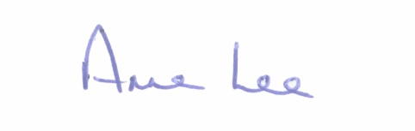
Signed: _______________
Anne Lee,
Meetings Administrator.

Confirmed and adopted at Monthly Meeting of Longford County Council held on the
10th January 2018.

Signed: _______________
Cathaoirleach.

